COAL Lab 12 Assignment:

# Name: Owais Ali Khan

# Section: 3-F

# Roll no: 21K-3298

Question # 01:

#include <iostream>

int main() {

int a, b, c, prod;

std::cout << "Enter three integers: ";

std::cin >> a >> b >> c;

_asm {

mov eax, a

mul b

mul c

mov prod, eax

}

std::cout << "Product is: " << prod << "\n";

return 0;

}

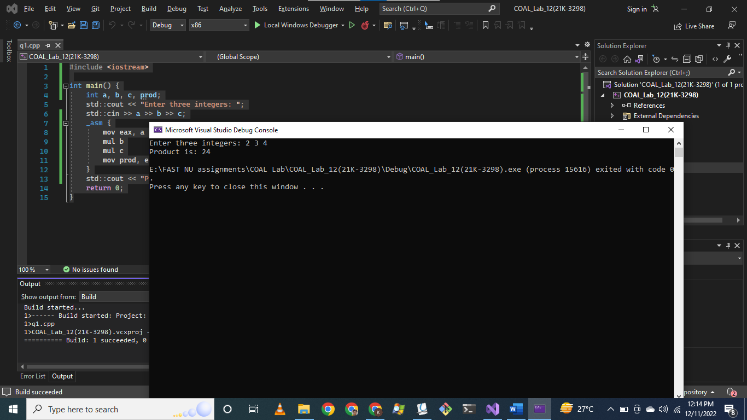

Question # 02:

#include <iostream>

int main() {

int num1, num2, gcd = 1;

std::cout << "Enter two numbers: ";

std::cin >> num1 >> num2;

_asm {

mov ecx, 1 // Iterator variable

GCD:

cmp ecx, num1

jg ENDD

cmp ecx, num2

jg ENDD

mov edx, 0

mov eax, num1

div ecx

cmp edx, 0

jne LOOP_GCD

mov edx, 0

mov eax, num2

div ecx

cmp edx, 0

jne LOOP_GCD

mov gcd, ecx

LOOP_GCD:

add ecx, 1

jmp GCD

ENDD:

}

std::cout << "GCD is: " << gcd << "\n";

return 0;

}

